Recursion

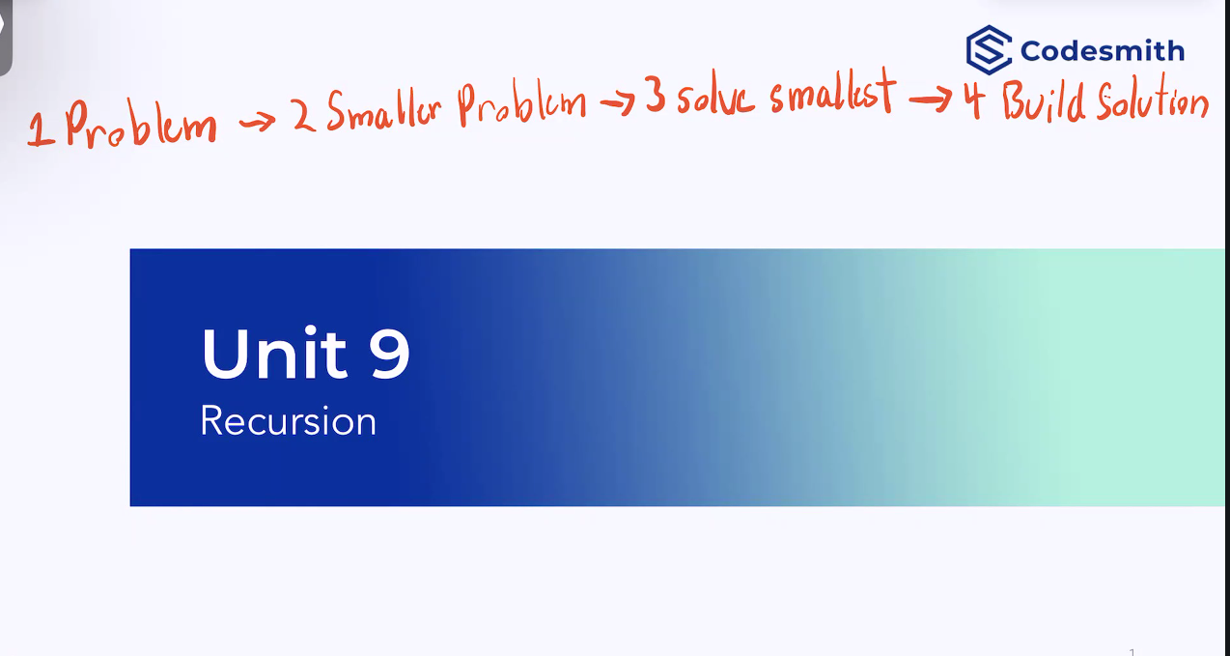

Imperative vs. Declarative

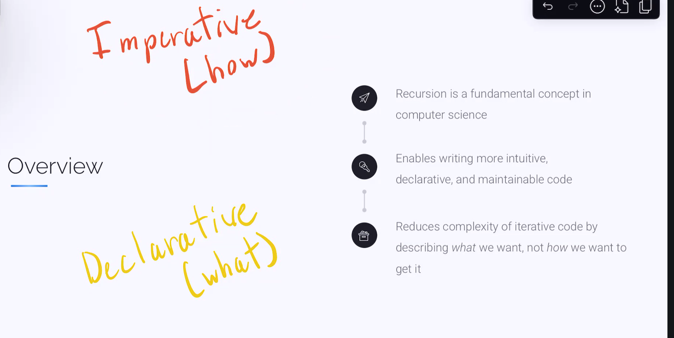

Principles of Javascript

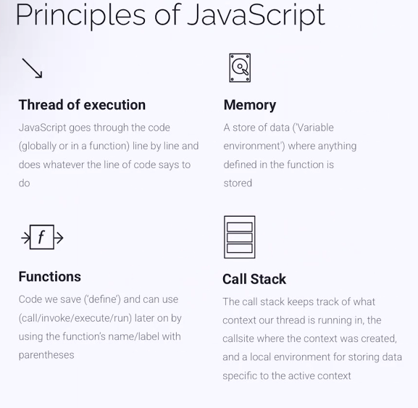

Thread of execution = it is single threaded. Goes line by line

Memory = a store of data “variable environment” where our functions are stored

Stack frame = the address where our value is returned to memory. When a function is invoked javascript is pushing this stack frame onto the call stack

Call stack or stack data structure.

Functions = code we save and can use later.

Repeating

tasks

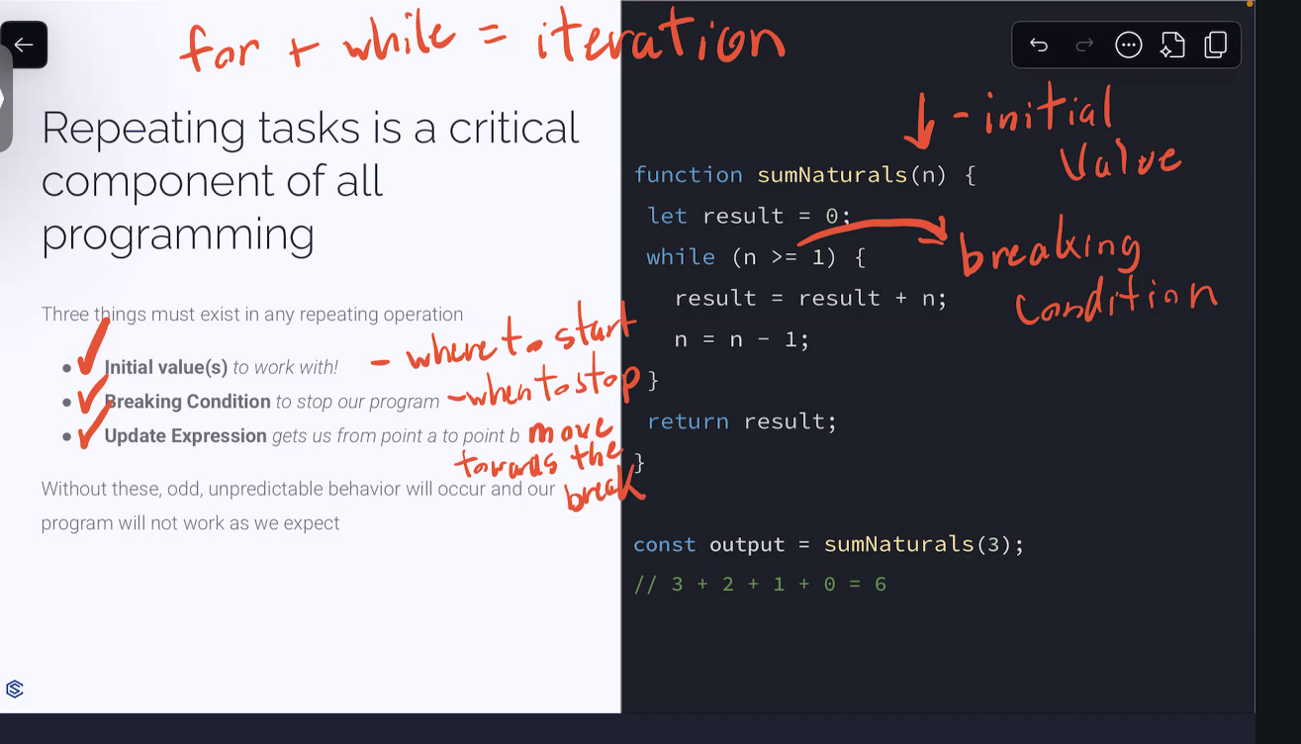

Local Execution Context of a recursion program

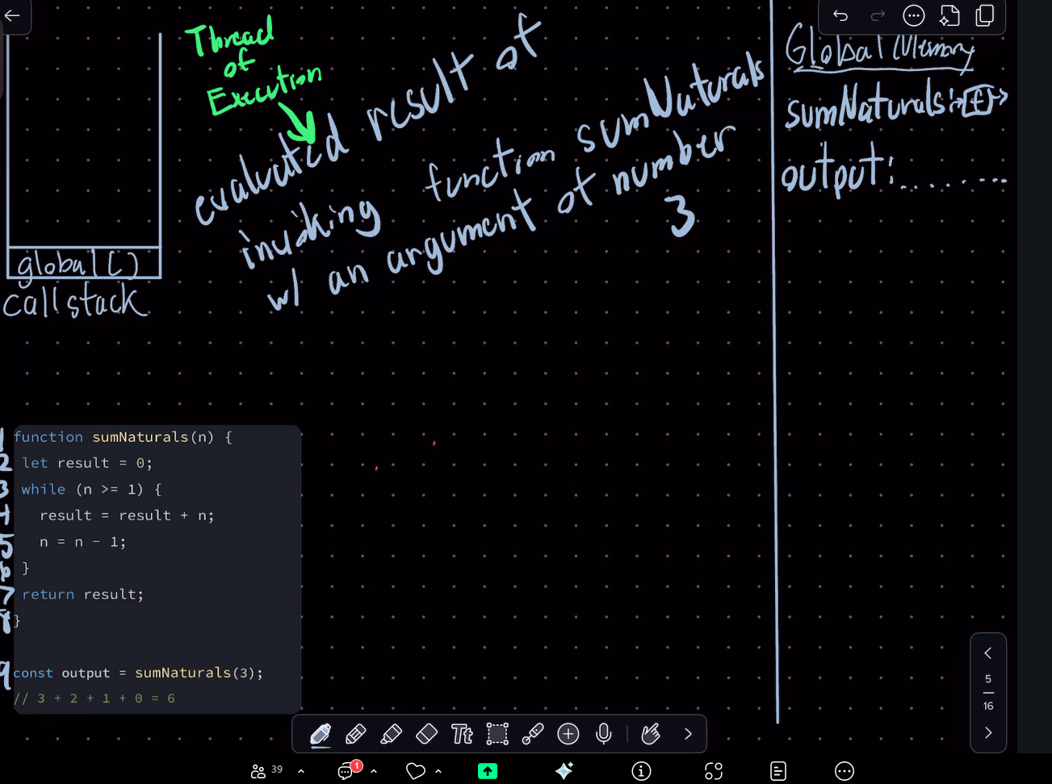

Pairing our argument with our function paraemeter

Variable declaration

(also known as a reassignment) Result = result + n

N = n-1;

Evaluated result of output

Const output = sumNaturals(3);

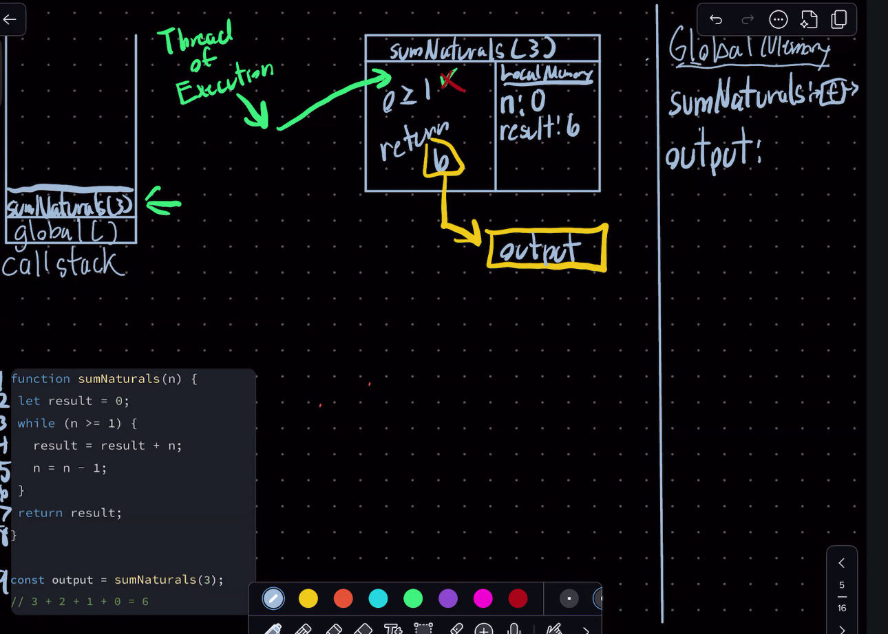

Marked for garbage collection



Pros and cons

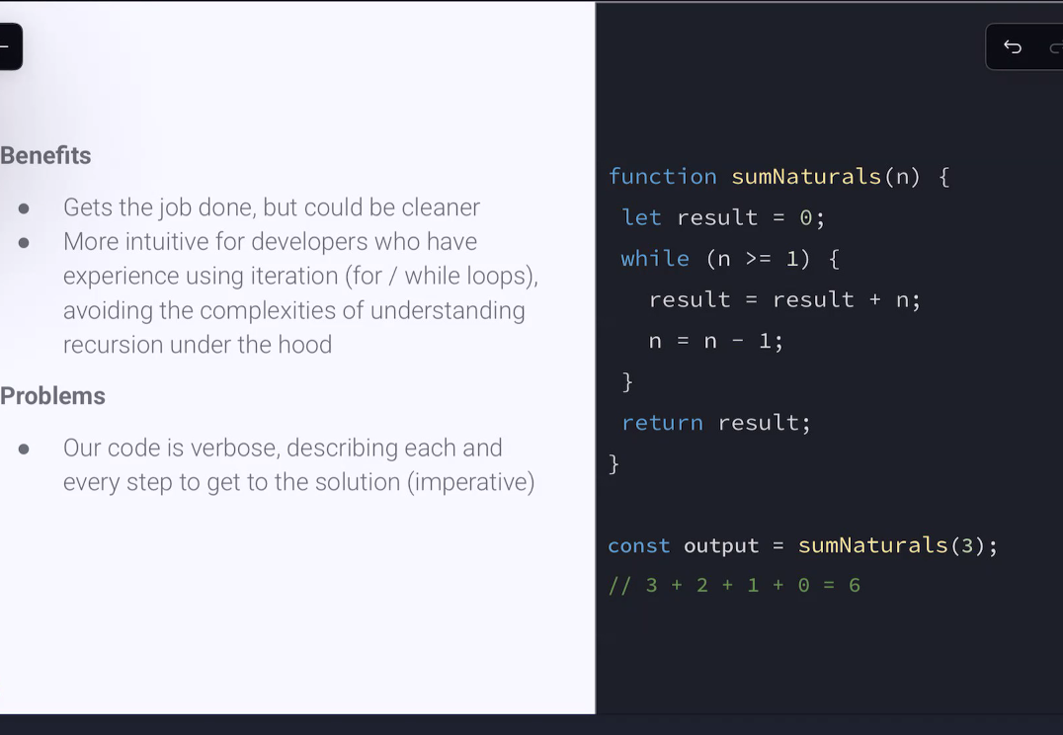

Recursion

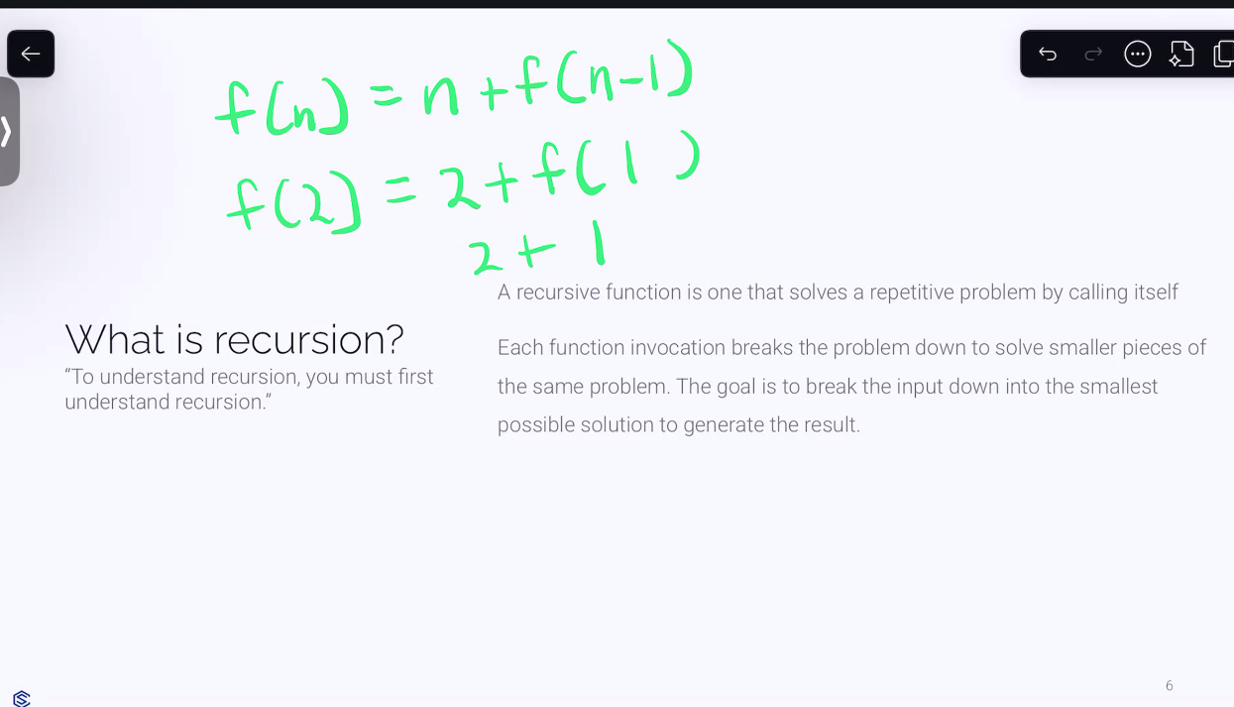

How do recursive functions work

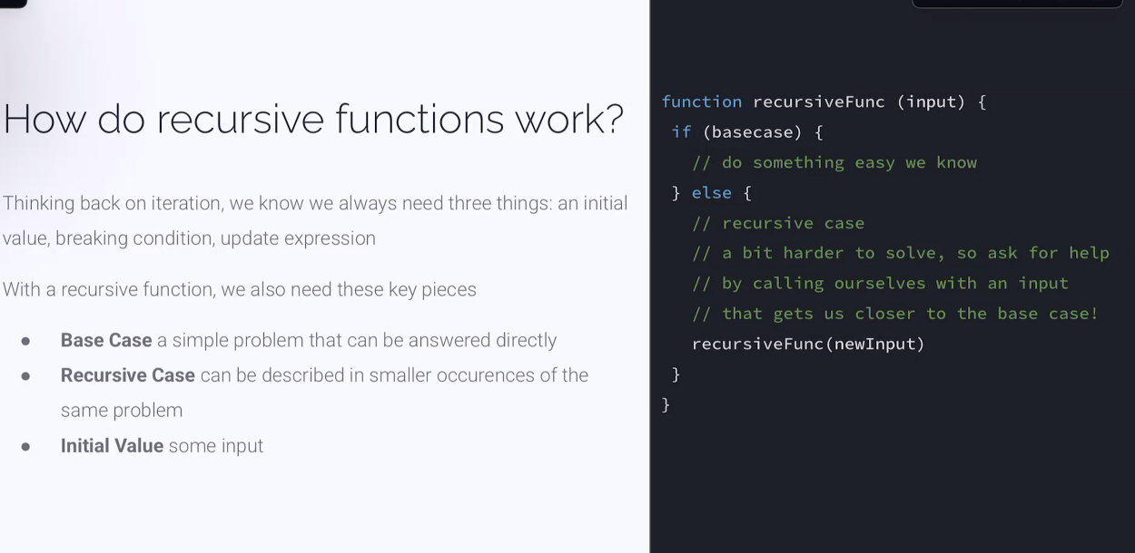

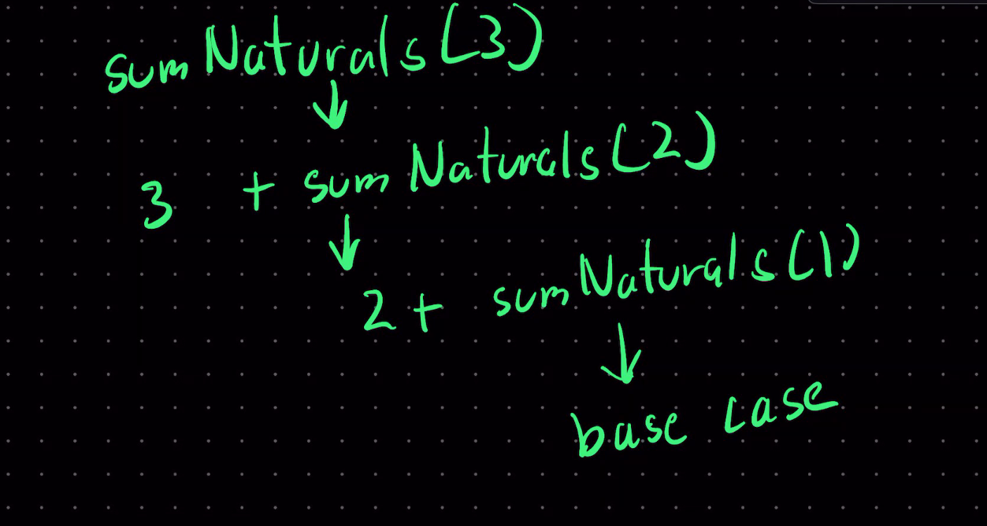

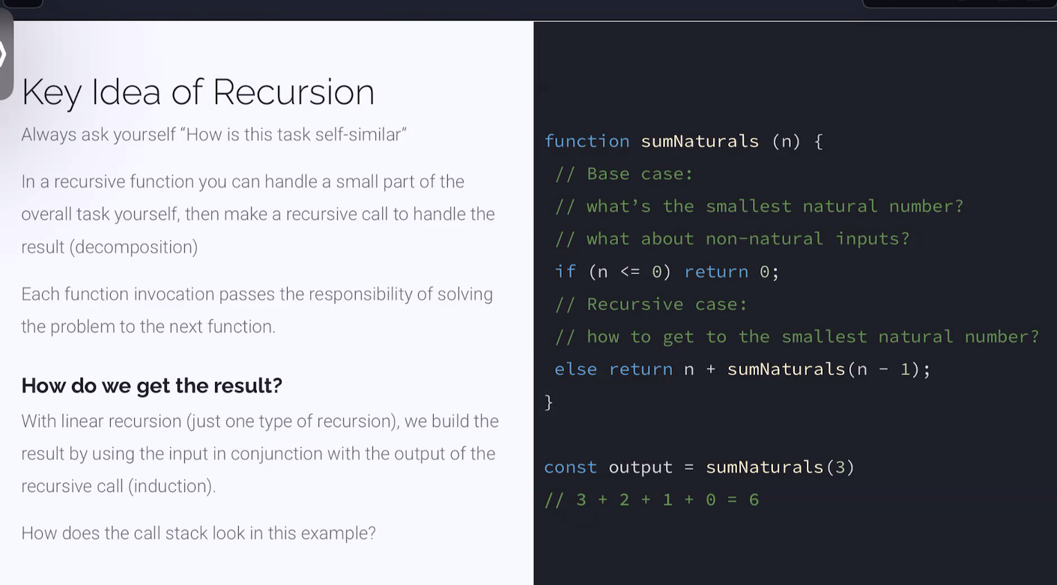

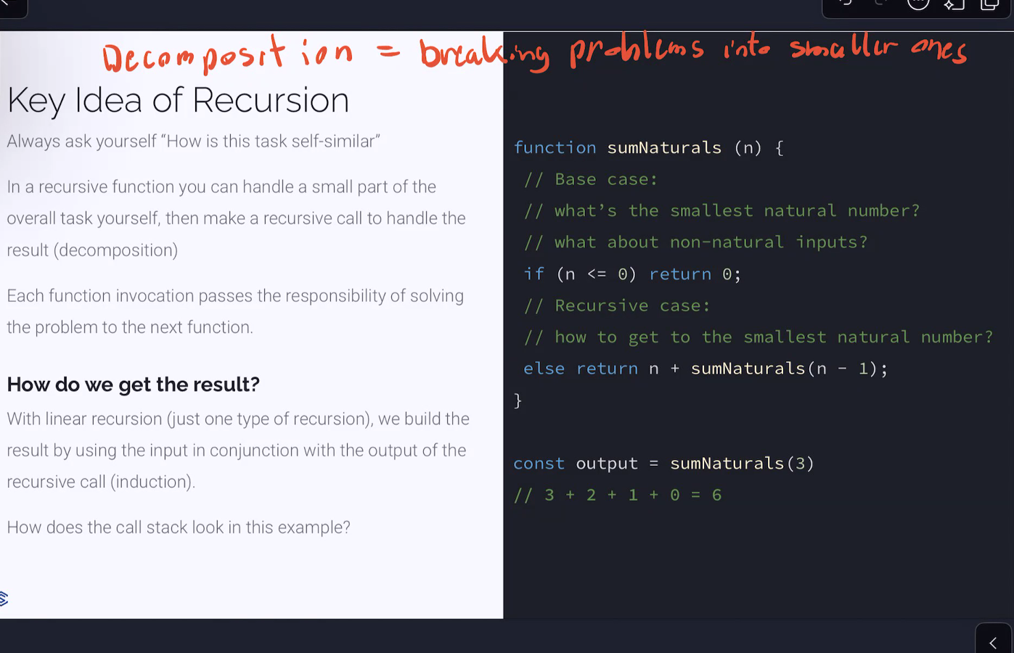

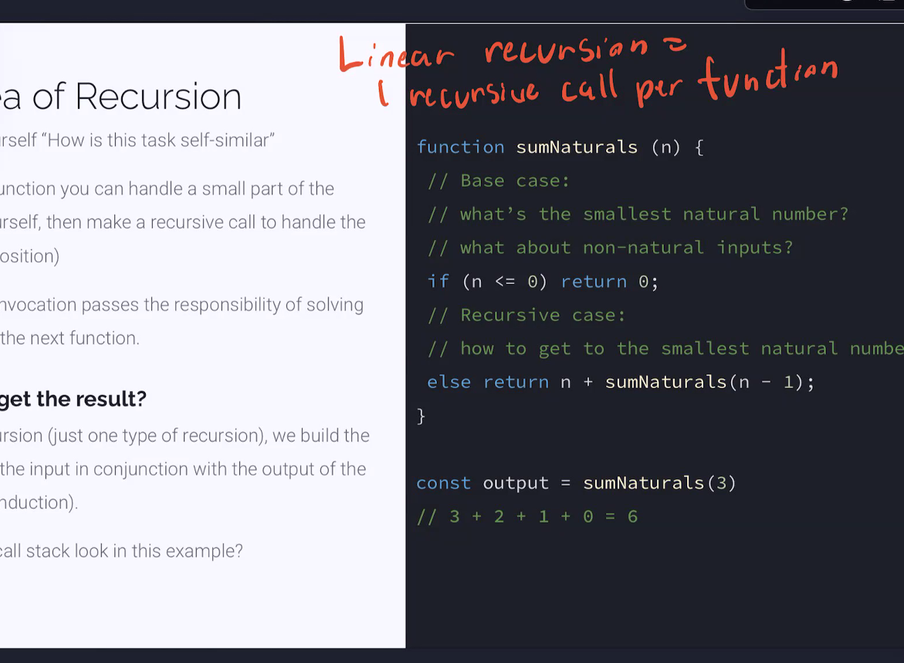function declaration

Function definition

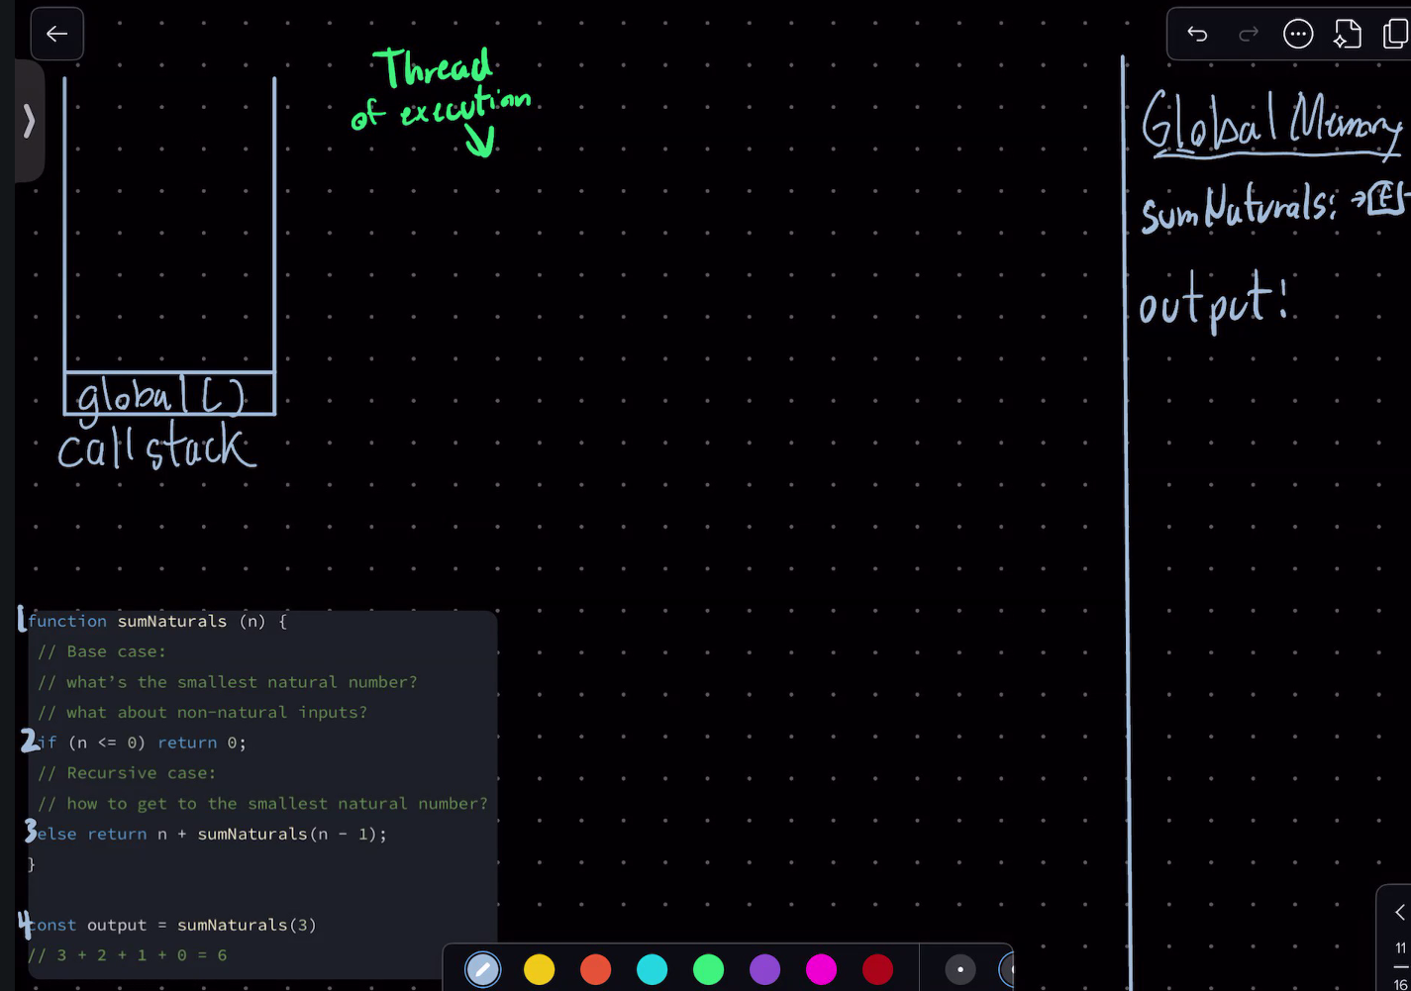

Declare variable with a function evaluated result of sum naturals with value 3

Open local execution

Push our stack frame into call stack weaving into the local execution context

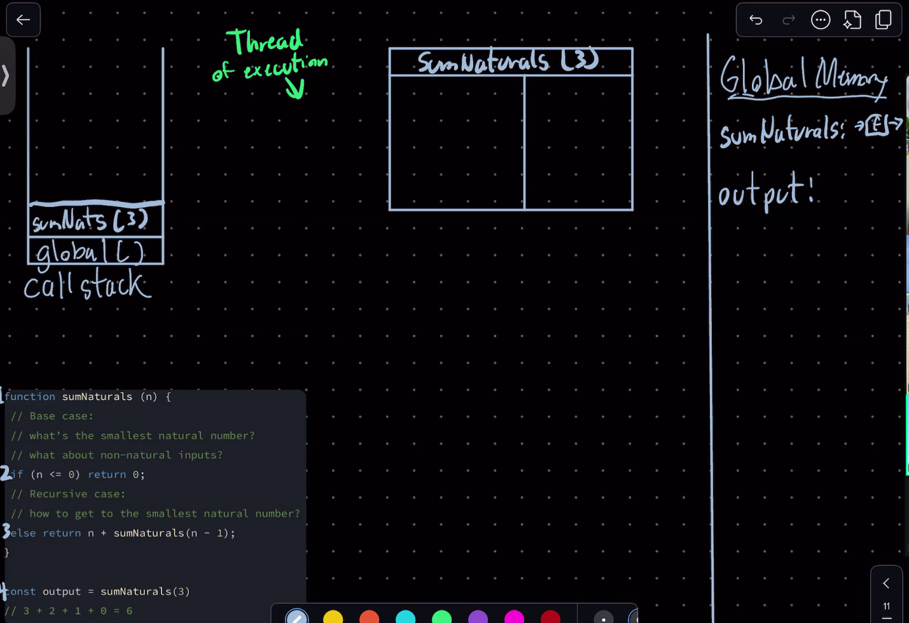

pair our arguments and parameters

n:3

go into our function

our second function was invoked

push another callstack sum nats 2

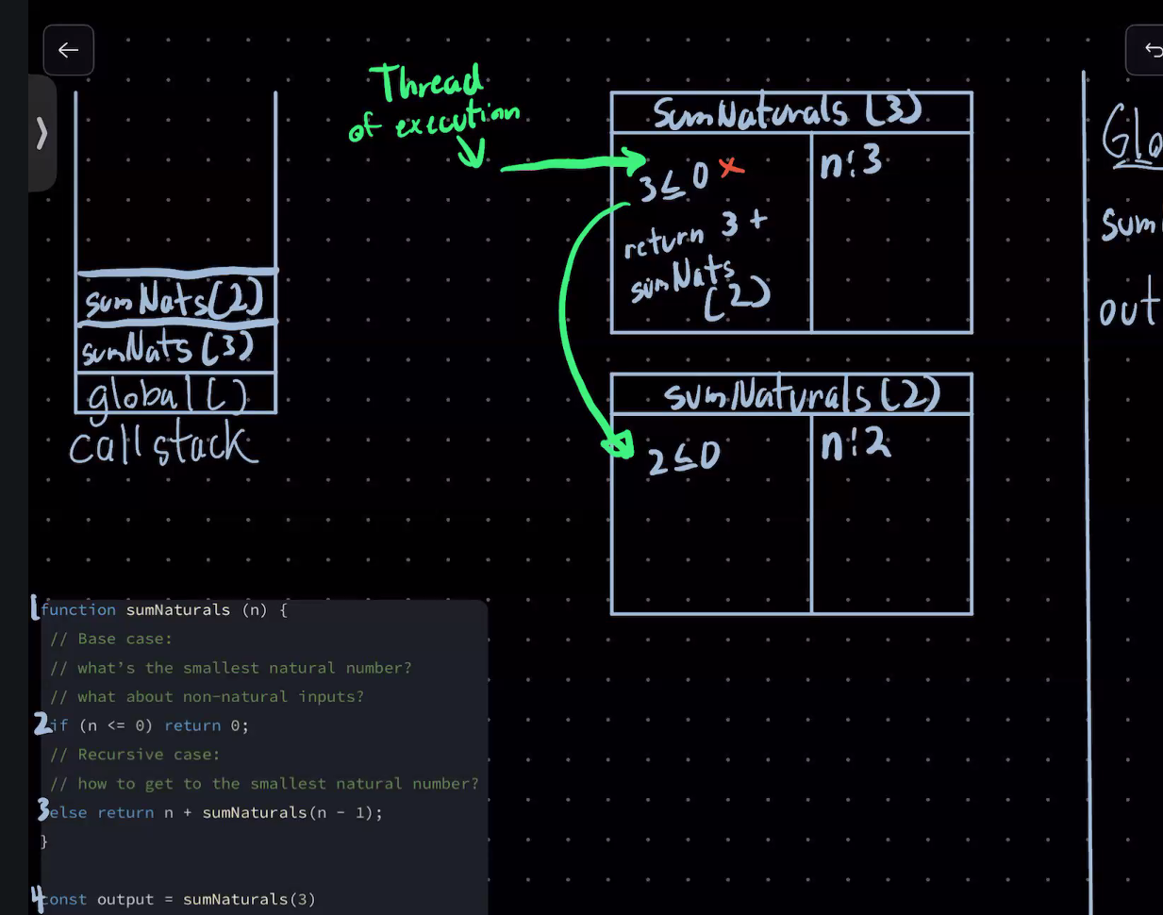

Push another call stack

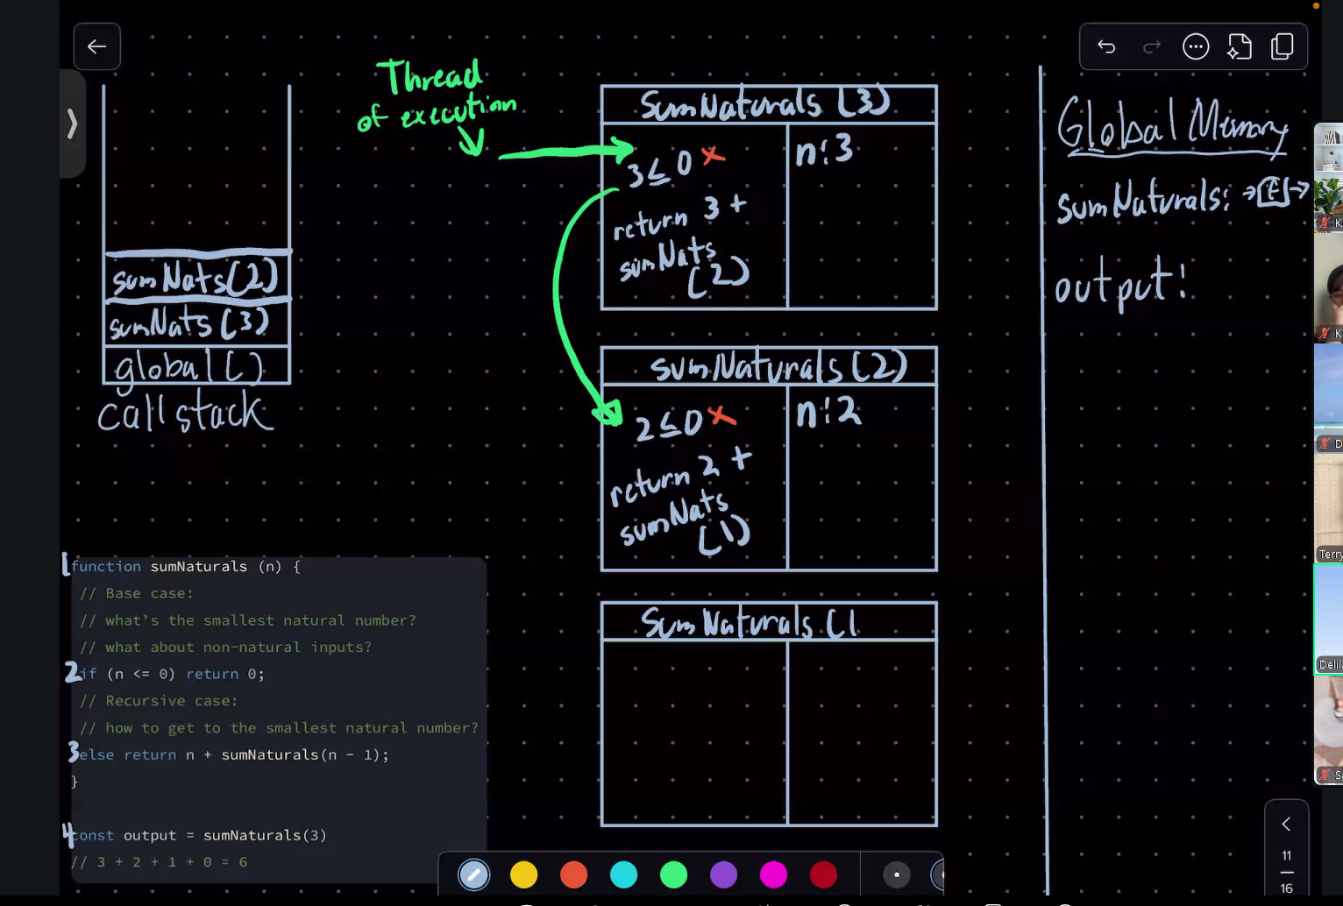

Evaluated result of sumnaturals

Another call stack

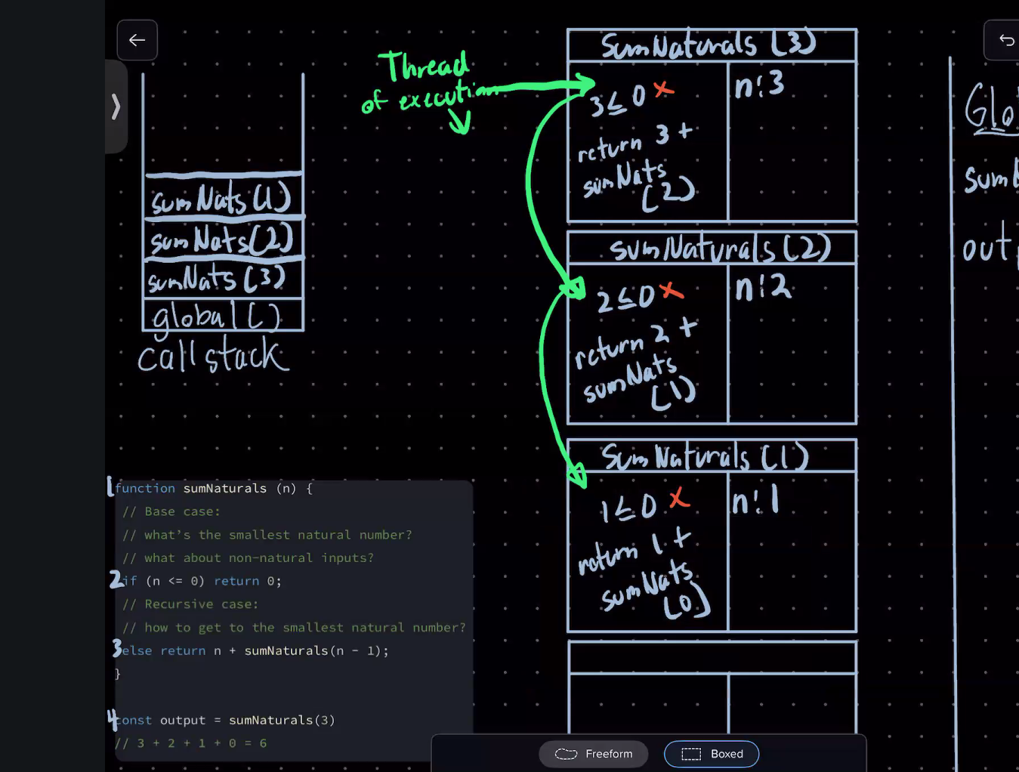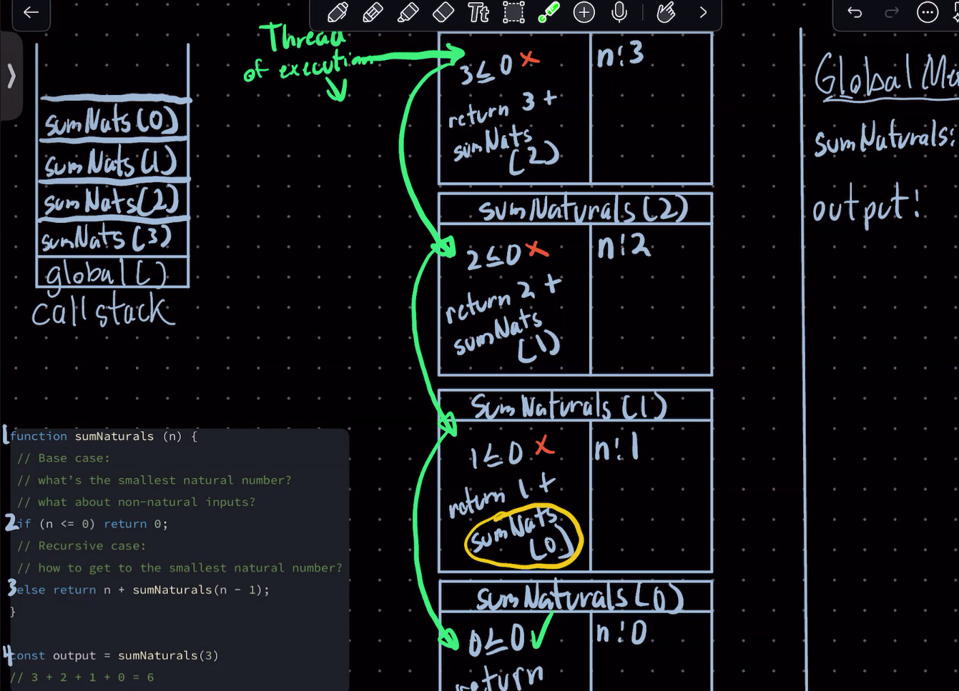

Output is our evaluated result

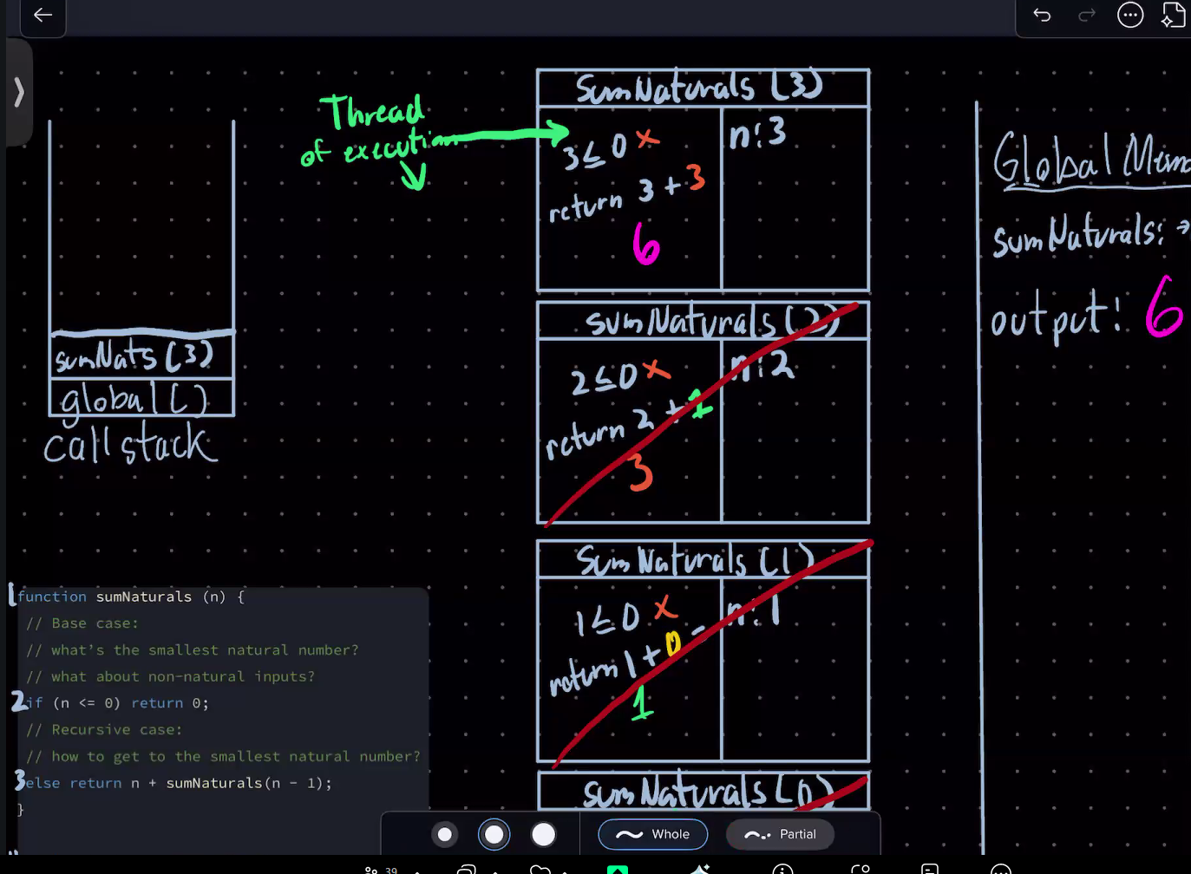

Tail call recursion

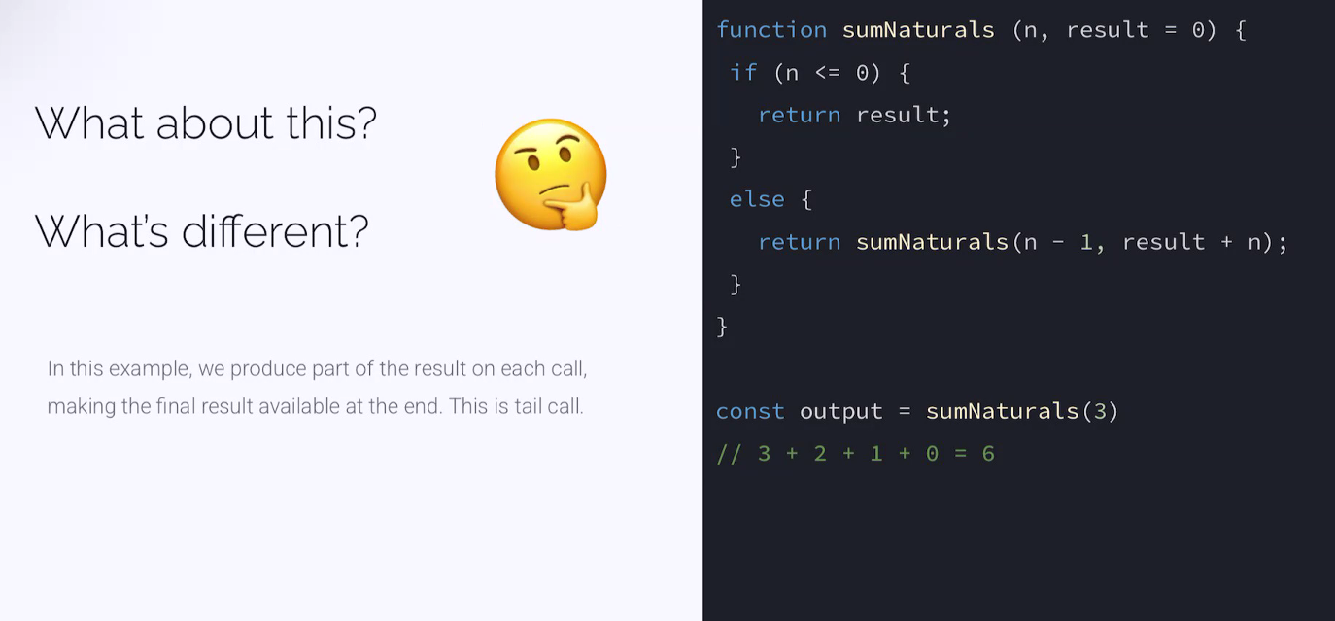

Tail call recursion breaking down

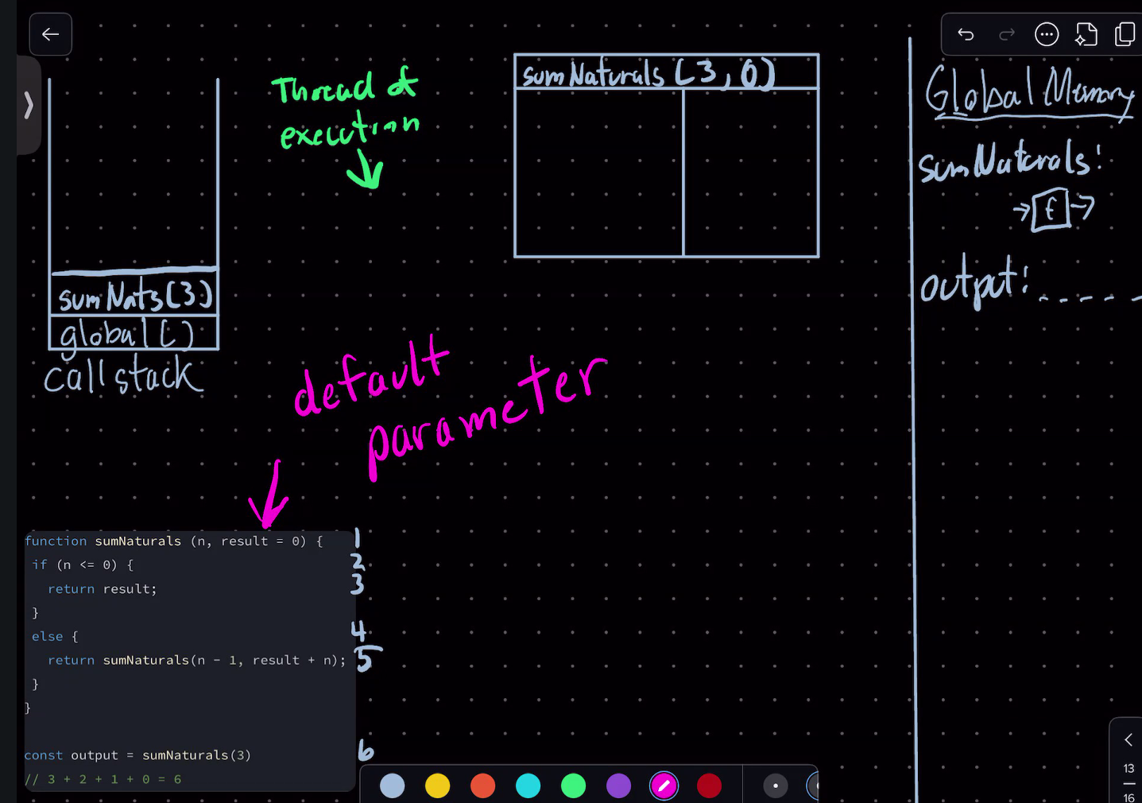

Other recursions

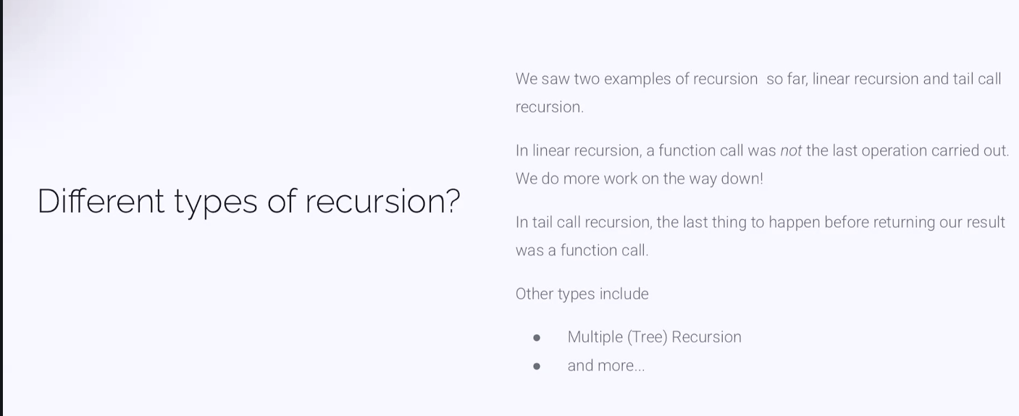

Fibonacci Sequence

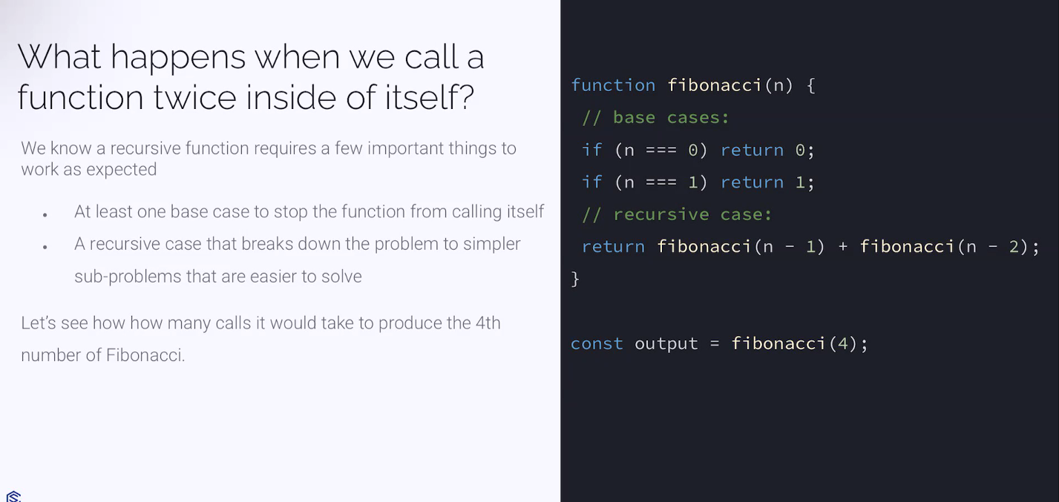

Tree recursion

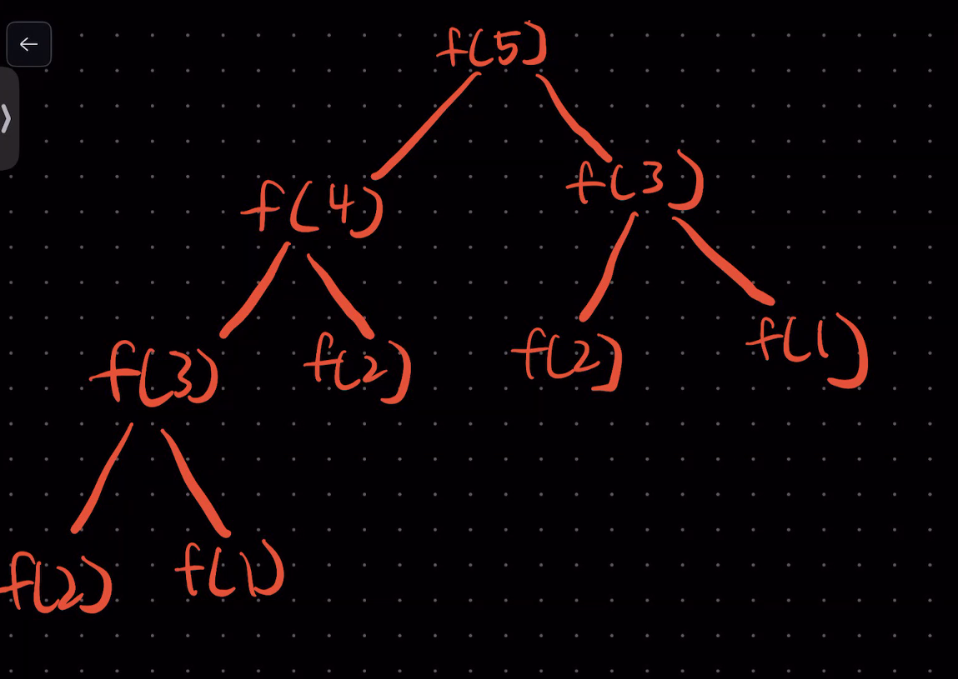

Fibonacci sequence

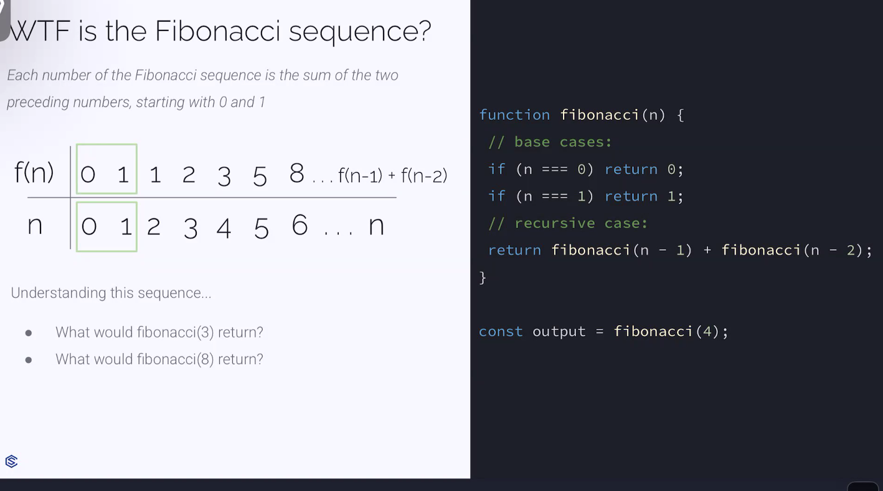

Base case is

n<2 || n===5 return n

If n>1 && n<5 return n-1

Then Fibonacci(n-1) + Fibonacci(n-2)

F0=0

F1=1

F2=1

F3=2

F4=3

F5=5

F6=8



